Encapsulation
Encapsulation in Java or object oriented programming language is a concept which enforce protecting variables, functions from outside of class, in order to better manage that piece of code and having least impact or no impact on other parts of program due to change in protected code.
Encapsulation in Java is visible at different places and Java language itself provides many construct to encapsulate members. You can completely encapsulate a member be it a variable or method in Java by using private keyword and you can even achieve a lesser degree of encapsulation in Java by using other access modifier like protected or public.
True value of encapsulation is realized in an environment which is prone to change a lot and we know that in software requirements changes every day at that time if you have your code well encapsulated you can better manage risk with change in requirement.
I.e. maintained in just one place and not scattered around code is easy to change. This can be better explained with a simple example of encapsulation in Java.
We all know that constructor is used to create object in Java and constructor can accept argument. Suppose we have a class Loan has a constructor and than in various classes you have created instance of loan by using this constructor. Now requirements change and you need to include age of borrower as well while taking loan. Since this code is not well encapsulated i.e. not confined in one place you need to change everywhere you are calling this constructor i.e. for one change you need to modify several file instead of just one file which is more error prone and tedious, though it can be done with refactoring feature of advanced IDE wouldn't it be better if you only need to make change at one place? Yes that is possible if we encapsulate Loan creation logic in one method say createLoan() and client code call this method and this method internally crate Loan object. in this case you only need to modify this method instead of all client code.
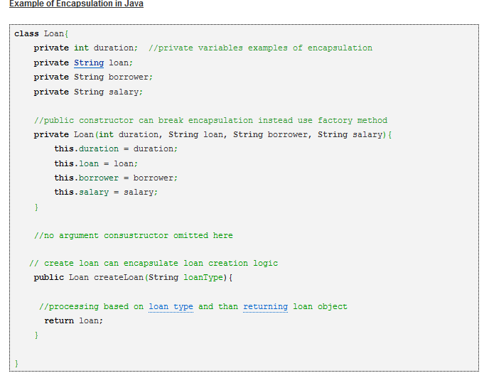

Advantage of Encapsulation in Java and OOPS
Here are few advantages of using Encapsulation while writing code in Java or any Object oriented programming language:

1. Encapsulated Code is more flexible and easy to change with new requirements.
2. Encapsulation in Java makes unit testing easy.
3. Encapsulation in Java allows you to control who can access what.
4. Encapsulation also helps to write immutable class in Java which is a good choice in multi-threading environment.
5. Encapsulation reduce coupling of modules and increase cohesion inside a module because all piece of one thing are encapsulated in one place.
6. Encapsulation allows you to change one part of code without affecting other part of code.

Design Pattern based on Encapsulation in Java
Many design pattern in Java uses encapsulation concept, one of them is Factory pattern which is used to create objects. Factory pattern is better choice than new operator for creating object of those classes whose creation logic can vary and also for creating different implementation of same interface. BorderFactory class of JDK is a good example of encapsulation in Java which creates different types of Border and encapsulates creation logic of Border. Singleton pattern in Java also encapsulate how you create instance by providing getInstance() method. Since object is created inside one class and not from any other place in code you can easily change how you create object without affect other part of code.

Important point’s about encapsulation in Java.
1. "Whatever changes encapsulate it" is a famous design principle.
2. Encapsulation helps in loose coupling and high cohesion of code.
3. Encapsulation in Java is achieved using access modifier private, protected and public.
4. Factory pattern, Singleton pattern in Java makes good use of Encapsulation.
http://javarevisited.blogspot.com/2012/03/what-is-encapsulation-in-java-and-oops.html#ixzz40CNDVUGV

